Resource and advice
Can I self-refer? GP referral

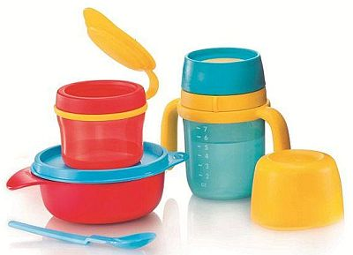
Feeding and nutrition:
1; Camden Heath Visitors - online Baby Feeding groups and support the Health Visiting virtual weekly clinic. See below for Yes ----
details of how to register for these sessions Mo & Thu 10.30-11.30 (zoom). open to all parents and carers with a
child under 12 months https://www.cnwl.nhs.uk/services/community-services/camden-baby-feeding-team

If you have a specific question for your Health Visitor about caring for your baby, please contact the

Health Visiting team at camden.dutyhv@nhs.net tel: 020 3317 3032.

2; Bright Start Breastfeeding Support – Islington: tel: 020 3316 8439 (breastfeeding helpline)

Islington Health visitors: tel: 020 3316 8008

3; Out of hours support for baby feeding is also available at the National Breastfeeding Helpline 0300 100 0212, Yes ---
9.30am to 9.30pm, 7 days a week.
4; First Steps Nutrition Trust is an independent public health nutrition charity. We endeavour to fill Yes ---
practical and policy-relevant information gaps and provide resources for health workers supporting
eating well from pre-conception to five years. https://www.firststepsnutrition.org/
5; Start4Life NHS: offers information on infant feeding during the COVID-19 pandemic https://www.nhs.uk/start4life Yes ---

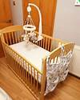
Sleep
1; Source Basis provides online access to up-to-date research-based evidence about infant sleep for parents and Yes ---
health practitioners, it does not address sleep problems.
https://www.basisonline.org.uk/
2: The Lullaby Trust gives guidance on how to reduce the risk of sudden infant death syndrome Yes ---
https://www.lullabytrust.org.uk/safer-sleep-advice/baby-room-temperature/

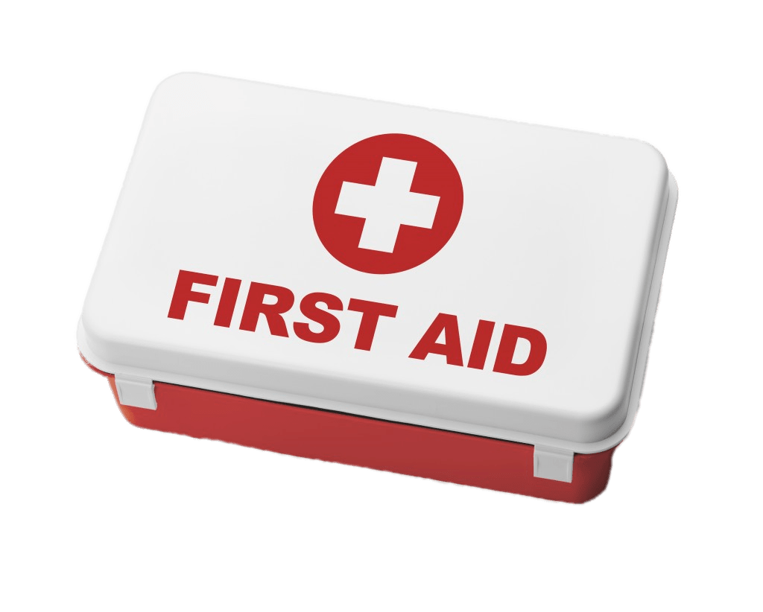
First-aid:
St John’s Ambulance: First aid for choking baby, child or adult - including what to do and when to get medical assistance. Yes
https://www.sja.org.uk/get-advice/first-aid-advice/choking/

Emergency help with nappies, toys and clothes:
Choices in Islington on Caledonian road: Baby clothes, equipment, formula, befriending and counselling No Yes
Happy Baby community: Ante-natal & post-natal support, New baby bundles, welfare advice, counselling No Yes
Pram depot: Baby bank that does emergency box's (nappies, clothes ect) No Yes
Little Village, and Small Project: Clothes up to age 5 years old No Yes
Baby groups and crash: - Please book in advance
Camden: Stay and Play in the park,
Thursday and Friday 10.30-11.30 Kilburn Grange 020 7974 5080
Tuesday and Thursday 10.00-11.00 Agar Children’s Centre: 020 7974 4789
Wednesday 10.00-11.00 Wilmington Sq 1a Children’s Centre: 020 7974 7024
Monday and Wednesday 10.30-11.30 Regents Park Children’s Centre: 020 7974 8934
Tue: 10.11am and Thu 2-3pm Harmood Children’s Centre 020 7974 8961

Islington: Find Children's Centres and Bright Start Services Bright Start North: 020 7527 8441
Bright Start Central: 020 7527 8465
Bright Start South: 020 7527 4089

Self-care for mums:
Women self-care (Camden Only) at Women+health
acupuncture, reflexology, massage, homeopathy, osteopathy, yoga, aromatherapy, short-term counselling, Yes Yes
half-hour GP advice session, short-term psychotherapy,
self-referral or if indicated GP can refer, you may need a proof of income for the discounted price https://www.womenandhealth.org.uk/
Self referral: tel:02074822786; e: stc@women-and-health.org

Parental and Family Support:
Family Support: The Winch
The Winch works with children, young people and families across North Camden to improve their chances in life. No Yes
It provides activities, opportunities and support from cradle to career, as well as an out-of-hours phone line and
access to additional services and support provided by partners in education, health, housing and general advice.
Services are divided by:
- 0-5s includes parents hub and rhyming
- 4-12s includes after school club, holiday play scheme, educational support
- 11-19s includes schools work, young leaders, sports activities, youth club
- 19-25s includes business start-up, volunteering, work experience, youth club

Women's Health Psychological Services (WHPS)
Service providing short-term, focused therapeutic consultation to parents with moderate psychological difficulties No Yes
related to pregnancy and childbirth. Service delivered by multi-professional team including counsellor, psychologist,
psychotherapist and trainees.
Consenting women and partners who are ready to work psychologically on their distress about the pregnancy,
pregnancy loss, fear of birth, serious birth complications and other pregnancy-related problems (excluding post-natal
depression).
Women and partners presenting complex social issues.

Contraception:
General advice on available choices: NHS UK https://www.nhs.uk/conditions/contraception/
Emergency contraception: https://www.nhs.uk/conditions/contraception/where-can-i-get-emergency-contraception/
Family planning clinic: for IUD, IUS and contraceptive implant Yes No
MSI UK’s Central London clinic: Marie Stopes House, 108 Whitfield Street, London W1T 5BE. Tel: 0345 300 2350
Citizen advice bureau (CAB): Advice is provided in relation to welfare benefits, debt, housing and a range of other No Yes
issues affecting individual welfare

Pre- and post-natal depression:
1; Home-Start Camden & Islington matches families going through a difficult time with a trained volunteer with parenting Yes Yes
experience. Volunteers do weekly home visits for 3-4 hours and provide non-judgemental, peer-to-peer support
(for self-referral call: 020 7424 1603)
2; If you feel you or someone around you is in the risk of pre- or post-natal depression, you can contact the GP, Midwife Yes
or the Health Visitor who is linked to the family for help and advice
3: Cocoon Family Support: Helping new and expectant parents to find their wings, providing support to parents affected currently suspended
by perinatal mental illness. https://cocoonfamilysupport.org/– service suspended till further notice
4: iCope: for mild to moderate pre-existing and/or long-term mental health problems can self-refer via phone or
though the website: 02033717600 http://www.icope.nhs.uk Yes Yes

Child protection
If you feel a baby or a child around you is in the risk of abuse, domestic violence, neglect or any other form of physical
or emotional harm, please contact GP or the health visitor who is linked to the family

Domestic violence, FGM:
1; National Domestic Violence Helpline 0808 2000 247 https://www.nationaldahelpline.org.uk/ Yes No
refer to emergency safe accommodation; provide information on legal, welfare and housing rights
online crisis and safety planning; emotional support and refer to counselling services

2; Camden Safety Net – Domestic Violence T: 020 7974 2526 e: camdensafetynet@camden.gov.uk Yes Yes
Camden Safety Net provides advice and support to male and female survivors of domestic violence and
sexual violence, including: counselling and therapeutic services
advocacy services, risk assessments and action plans to enhance safety
same-sex domestic and sexual violence support
referrals to appropriate agencies such as women's aid refuges, housing, legal services, parenting support
Support is appropriate to the survivor's language, culture and religion.
Self-refer by email, telephone or SMS. SMS text phone number: 07814 671427

3; Men’s Advice Line for men experiencing abuse: Monday–Friday 9am–5pm – t: 0808 801 0327
4; Galop (National LGBT Domestic Abuse Helpline) – t: 0800 999 5428
5; RESPECT Phoneline: Confidential helpline offering advice, information and support to anyone concerned about their own or someone else’s violent or abusive behaviour. Monday–Friday 9am–5pm – t: 0808 802 4040

